Exercise 1. Read and comprehend the text bellow and be ready for teacher’s questions:
Part V. Money
Text 15. The History of Money
The use of money is as old as the human civilization. Money is basically a method of exchange, and coins and notes are just items of exchange. But money was not always the same form as the money today, and is still developing.
The basis of all early commerce was barter, in other words the direct exchange of one product for another. Subsequently both livestock, particularly cattle, and plant products such as grain, come to be used as money in many different societies at different periods. Cattle are probably the oldest of all forms of money.
People in early societies developed forms of proto-money – the use of commodities that everyone agreed to accept in trade. Various items have been used by different societies at different times. Aztecs used cacao beans. Norwegians once used butter. The early U.S. colonists used tobacco leaves and animal hides. Human slaves were also used as currency around the world. In the 16th century, the average exchange value of a slave was 8000 pounds of sugar.
Outside China, the first coins developed out of lumps of silver. They soon took the familiar round form of today, and were stamped with various gods and emperors to mark their authenticity. These early coins first appeared in the Kingdom of Lydia (now in Turkey) in the 7th century B.C., but the techniques were quickly copied and further refined by the Greek, Persian, Macedonian, and later the Roman empires. Unlike Chinese coins, which depended on copper, these new coins were made from precious metals such as silver, bronze, and gold, which had more inherent value. As in so many other things, the Chinese were the innovators for the next step. The Chinese invented printing, and not too much later, they also invented paper money during the T'ang Dynasty. During Ming Dynasty the Chinese placed the emperor's seal and signature on a crude paper made from mulberry bark. In all, China experienced over 500 years on early paper money, spanning from the ninth through the fifteenth century. Then beginning in 1455, the use of paper money in China disappeared for 700 years. People in Mongolia were the second who began to use paper money in the eleventh century.
Paper money was adopted in Europe much later than in Asia and the Arab world – primarily because Europe didn't have paper. The first paper mill in Europe was established by the Moors in 1151 A. D. in what is now Spain, but paper was not widely accepted because of religious prejudice.
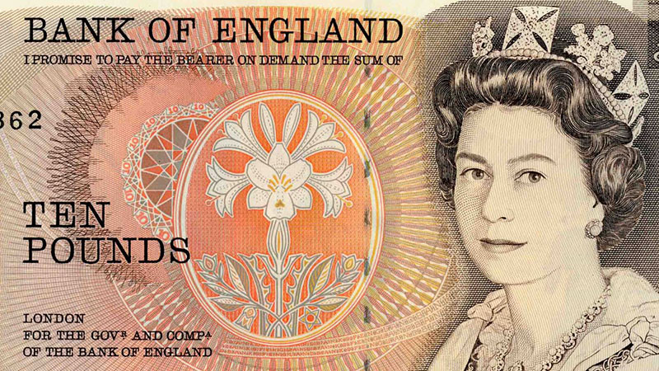
The Bank of Sweden issued the first paper money in Europe in 1661, though this was also a temporary measure. In 1694 the Bank of England was founded and began to issue promissory notes, originally handwritten but later printed. To make travelling with gold less dangerous, people who made jewelry and other items out of gold, came up with an idea. The goldsmiths started writing out notes on pieces of paper that said the person who had the note could trade the note in for gold. These promissory notes were the beginning of paper money in Europe. If you look at a British bank note today, you'll see it still says: “I promise to pay the bearer on demand the sum of twenty pounds.”

vocabulary of hard-to-remember words and economic terms
refine | |rɪˈfaɪn| | təkmilləşdirilməsi, saflaşdırmaq
inherent | |ɪnˈhɪrənt| | xas olan
seal | |siːl| | möhür
crude | |kruːd| | xam
span | |spæn| | əhatə etmək
mill | |mɪl| | dəyirman, zavod
prejudice | |ˈpredʒʊdɪs| | xurafat, qərəz
promissory | |ˈprɑːməˌsɔːrɪ| | veksel
jewelry | |ˈdʒuːəlrɪ| | zərgərlik
goldsmith | |ˈɡəʊldsmɪθ| | zərgər
Exercise 2. Insert as … as or so … as:
1. Mike is … tall … Pete.
2. Kate is not … nice … Ann.
3. My room is … light … this one.
4. This book is not … thin … that one.
5. Sergei is … old … Michael.
6. She is … old … Tom’s brother.
7. This woman is … good … that one.
8. Nick’s English is not … good … his friend’s.
9. I am not … thin … you.
10. This woman is … young … that one.
11. I am … thin … you.
12. Kate is … lazy … her brother.
13. This child is not … small … that one.

Exercise 3. Open the brackets using the required form of the adjective.

- We should eat (healthy) food.
- Today the streets aren't as (clean) as they used to be.
- It's the (bad) mistake he has ever made.
- This man is (tall) than that one.
- Asia is (large) than Australia.
- The Volga is (short) than the Mississippi.
- Which building is the (high) in Moscow?
- Mary is a (good) student than Lucy.
- The Alps are (high) than the Urals.
- This garden is the (beautiful) in our town.
- She speaks Italian (good) than French.
- Is the word “newspaper” (long) than the word “book”?
- The Thames is (short) than the Volga.

Exercise 4. Translate into English:

1. “Big Mac” indeksinə görə, manat son 6 ayda öz dəyərini ən azı 3 dəfə itirib.
2. Azərbaycanda kreditə avtomobil alarkən ilkin ödəniş yarıya endirilə bilər.
3. Türkiyə ilə Ukrayna arasında sərbəst ticarət sazişi imzalanıb.
4. Mikayıl Cabbarov İtaliya şirkətlərini Azərbaycanla fəal əməkdaşlığa dəvət edib.
5. Belarus Ukraynaya etiraz notası göndərib.
6. Səlim Müslümovun həbs müddəti uzadılıb.
7. Avropa Mərkəzi Bankı uçot dərəcəsi ilə bağlı gözlənilən qərarı verdi.
8. Gömrük yeni elektron xidmətini istifadəyə verib.
9. İngiltərə Bankı faiz dərəcəsini qaldırıb.
10. Ermənistan tərəfi Rusiya vasitəsilə Azərbaycana təkliflər göndərib.

