How to describe a picture in English?
Sample / Follow the structure I see - I think - I feel
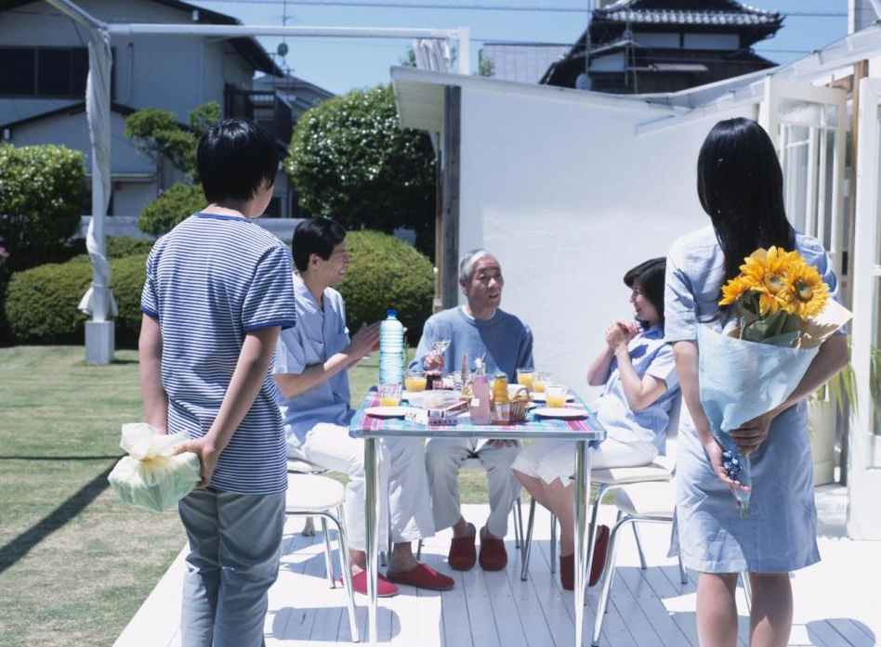

I see: There are 5 people in this picture. I can see a table outside, there is some food on it.3 people are chatting and smiling.
I think: I think they are a family. It looks like a weekend as the people seem relaxed. Maybe, it’s a birthday or a special day because young people are holding flowers and a present.
I feel: I like this picture because I love celebrating something with my family. This photo makes me happy and relaxed.

1) Helpful words and phrases to describe images:
The picture shows …
The picture illustrates …
The picture demonstrates …
In the center / middle of the photo we can see …
In the foreground there is …
In the background there are …
It is situated in …
On the left (of something / somebody) stands …
On the right (of something / somebody) sits…
In the distance we can make out the outline of (something / somebody)
At first glance, …
But if you look closely, you can see …
It looks strange …
It looks like ….
As for the (of something /somebody), …

Prepositions that are necessary when describing a photo (image, picture)
above — The woman is holding an umbrella above her head.
under (below) — The people are sitting under the tree.
near — The children are playing near the river.
next to —The girl is sitting next to the boy.
far — In the far distance I could hardly see a woman.
behind — Somebody is hiding behind the house.
in front of — In front of the building there is a fountain.
across — А dog is running across the road. There is a forest across the river.
around —There are a lot of stones around.
between — The woman is standing between two men.
on — The boats are sailing on the lake.

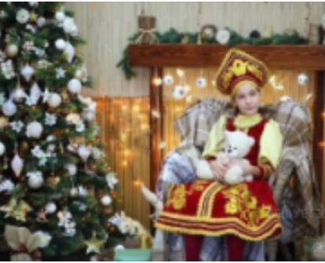
Some examples of a complete description of photos (images, pictures)
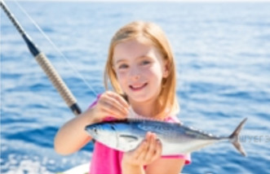
I’d like to describe picture № 2. The picture shows us a girl. The photo was taken outside. Maybe the action is taking place on a boat in the sea.
Looking at the photo, I can see a girl. She looks happy. She's just caught a fish. She is probably fishing in the sea on a boat with her parents. They probably took this picture. The weather is very nice and the sun is shining.
I like this photo because the girl is having a great time fishing. I love fishing too!
I’d like to describe picture № 1. The picture shows us a girl. The photo was taken inside. The action is taking place in a room.
Looking at this photo, I can see a girl who's sitting in a chair near the Christmas tree. It's decorated very well. The girl is holding a teddy bear in her hands. Maybe it's a Christmas present from her parents. The girl is dressed in traditional Russian clothes. She is smiling.
I like this photo because the girl looks happy. She's going to have a great time celebrating Christmas.

I’d like to describe picture № 3. The picture shows us an elderly man. The photo was taken inside. Maybe the action is taking place in the library.
Looking at the photo, I can see an elderly man who is in the library. He is holding a book in his hands and looking at the photographer. He's dressed well. Maybe he is a teacher at school or at the university. There are a lot of books on the desk in front of him. He probably read them all, or perhaps he's going to read them in the future.
I like the photo. I think this man is very knowledgeable because he reads a lot of books.

Describe following pictures:
