Exercise 1. Choose the correct variant:

1. … spiders are dangerous.
a) these
b) this
c) that

2. Those … are lovely.
a) girls
b) girl
c) girles

3. My granny is afraid of …
a) mouse
b) mouses
c) mice

4. It isn’t …. goose. It’s …. turkey.
a) a, the
b) a, a
c) – , a

5. ... are my clothes, don’t take them.
a) this
b) these
c) that

Exercise 2. Correct any mistakes in the following sentences:

1. That Frenchmen was really nice.
2. My uncle’s sheeps give perfect wool.
3. People should eat much fruit and vegetable daily.
4. Those pet has to eat twice a day.
5. I have enjoyed both comedy at the theatre.
6. The women went to the dentist because she had a teethache.
7. Some childs prefer much ice-cream.
8. My left feet really hurts.
9. Twelve oxes took part in the corrida in Spain.
10. Several classen went to the circus last week.
Exercise 3.
a) Determine the part of speech of the following words:
b) Make one sentence for each of the following words:

- uncle
- anchor
- dolphin
- student’s book
- breakfast
- lunch
- dinner
- line
- church
- monastery
- thousand
- buckwheat
- knowledge
- furniture
- celebration
- The Indian Ocean
- The Red Sea
- The Mediterranean Sea
- The English Channel
- The Thames
- The Earth
- to be tired
- to use
- to be situated
- to leave
- to fall asleep
- to prefer
- to admire
- beautiful
- young
- warm
- popular
- delicious
- touristic
- expensive
- abroad

Exercise 4. Read and comprehend the text bellow:

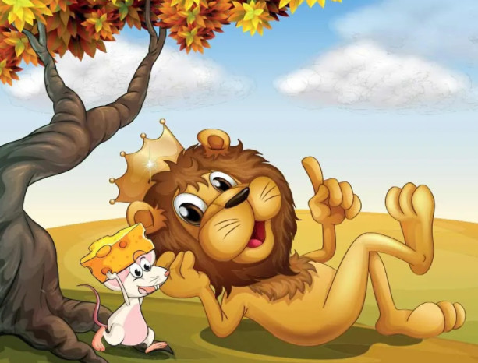
The Lion and the Mouse

A lion was once sleeping in the jungle when a mouse started running up and down his body just for fun. This disturbed the lion’s sleep, and he woke up quite angry. He was about to eat the mouse when the mouse desperately requested the lion to set him free. “I promise you, I will be of great help to you someday if you save me.” The lion laughed at the mouse’s confidence and let him go.
One day, a few hunters came into the forest and took the lion with them. They tied him up against a tree. The lion was struggling to get out and started to whimper. Soon, the mouse walked past and noticed the lion in trouble. Quickly, he ran and gnawed on the ropes to set the lion free. Both of them sped off into the jungle.

